Usability Findings – CourseCompass Portal
Chatree Campiranon, 12/8/05

Executive Summary

This usability study focused on the Teaching Port Home page and the Create and Copy course and Announcements features for CourseCompass. Users were instructors who have used CourseCompass and its related products, such as MyMathLab or MathXL.

Overall, users provided positive feedback on the new design. Most of the users understood the process being investigated. The change in branding will not be an issue.

Users were pleased to see that the Course page (in Bb) in the new design will be the same one that they have used in the past.

Users understood that the Portal page is the main focus of the redesign, and that it will point to the same course.

Findings

Portal page and Branding

- Portal page and branding changes did not bother users. None of the users had negative opinions regarding the phrase “Teaching Port”. None of the users mentioned the absence of tools, tab navigation, or the Preview/adopt and Browse by Imprint features. All of the users were accepting of the new design and branding.

- Users were divided on the amount of information that should be displayed on this page. Some users wished to see less information on this page, while others wanted to see more information displayed here, such as Class Schedule and Location.
Users found the presentation of Course ID useful. Users did not feel that the display of student enrollment numbers was necessary.

Recommendation
Course information and Course details will need some additional enhancements. Provide editing tools, such as an editing area with checkboxes, for users to customize components that they want to display as Course details.

- Three of the four users preferred to open courses in new browser windows. This confirms the findings from the previous usability study.

- All of the users appreciated the Portlets displayed on the Portal page. Users commented that a lot of information was available on the Portal page, yet the display was not overly crowded. Users felt that the placement on the page for each of the Portlets was accurate.

- Most of the users understood the My Resources feature, but one user thought that the feature would be used to upload her own files.

Recommendation
Suggest renaming the “My Resources” section to avoid confusing users.

Create and Copy Course

- All of the users expected the newly created course to be available immediately following the course creation process. However, sometimes the course creation takes additional time.

Recommendation
Include a notification to inform users of the length of time course creation might take. The notification should appear as the user starts the course creation process. Also, in the peak period of course creation, around the beginning of the fall semester, there should be an additional system announcement alerting users to this issue.

One user suggested that the notification include a specific time for the user to check back. For example, “the course will be created by 4pm tomorrow.”

- Most of the users understood what an E-Book version was. All of the users understood what the “what version should I choose?” link was for; however, they thought the phrase was too long, and felt that switching the phrasing of the link to “what’s this?” would be useful. See picture below:

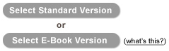

- The steps for Creating and Copying courses were deemed clear and straight forward by the users. Instructions were considered clear and easy to understand. The users liked that the selected book will be displayed on the following page after the user has selected a book.
Users said that they need Back and Cancel buttons. One user asked if the information she input would be if she used the Back button.

Recommendation
One user suggested that information that has already been input by the user should be stored if the user clicks on the Back button. At minimum, a message warning the user that their information will be lost should appear if the user clicks on the back button. The message should include Ok and Cancel buttons to allow the user to choose whether or not to continue.

- Most of the users preferred the combined step of selecting course components and entering course information.
One user did note that her preference would be to scroll down through the process rather than click through multiple pages.
All of the users felt the name “Select Course Components and Enter Course Information” was adequate. They thought the name was long, but easy to understand.
See picture below:

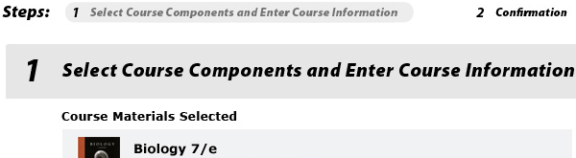

- Most feedback regarding the available options for creating and copying courses was positive; however, only one of the four users liked that all of the options were displayed together. All of the other users felt that housing all of the options together was overwhelming.

Recommendation
Combine the Create and Copy course features on one page, but do not bunch their options together.

See picture below:

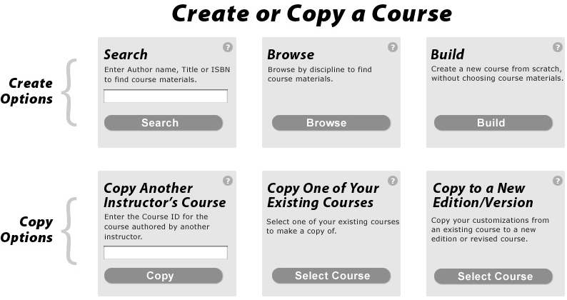

The picture below presents one of the possible “combined” solutions suggested by Rich Evers:

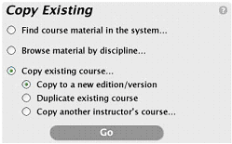

- The users’ search preferences were mixed. Different users opted to search by Author, title, and ISBN. Users appreciated the display of the search terms on the results page, and that tools were available to refine the search.

- The availability of multiple buttons for each course causes confusion for some users. During one of the usability study exercises, a user accidentally selected the Companion web site Create button rather than the CourseCompass Create or Copy button (see picture below):

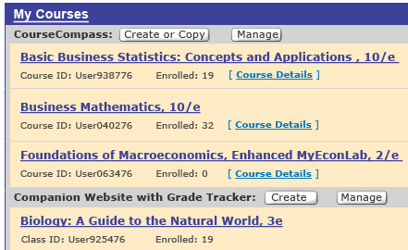

Recommendation
Users would prefer to have one big Create button rather than multiple buttons for each course, the design could be consistent by having one Create course button.

Announcements

- All of the users understood System and Course Announcements. None of the users understood Notifications. All of the users in this study stated that it is unlikely they will create notifications for multiple courses.

Recommendation
The Announcements could be duplicated in the Course Announcement section, and then Notifications could be removed to avoid confusion.

Note: One user suggested renaming Notifications as “Multi-Course Announcements” instead.

- Most of the users preferred the Create Announcement and Manage Announcement buttons displayed only once at the top of the section, rather than having multiple buttons scattered throughout the section. Users did not dislike the multiple buttons option, but large buttons at the top of the page were easier for them to see.
Also, the Announcements section will have a more organized appearance if only the two buttons are featured at the top of the section, rather than buttons for each section, plus Edit links for each Announcement and Add links for each Course. See comparison in the pictures below:

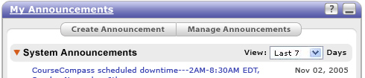

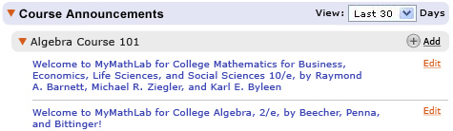

- Three of the four users preferred to see a page with a single Announcement up front rather than a page with all Announcements anchored to that single Announcement.

- All of the users liked the Expand/Collapse controls in the Announcement Portlet. However, one user mentioned that she would not like this option to be available for students since they might miss a message from an instructor. One user mentioned that she Collapses the System Announcements.

- All of the users liked the Filter control. They preferred the default to be thirty days for Course Announcements and seven days for System Announcements.
Users also liked the “New” icon that indicated new messages. As in e-mail, new messages should refer to unread messages.

- All of the users thought of Announcements as quick, short alerts. One user stated that his Announcements are usually 3-5 paragraphs in length. None of the users thought the feature was complicated.

- All of the users preferred to use checkboxes for choosing multiple courses. Clicking arrows to add selected courses was the least desirable method to the users.

- All of the users considered the Create Announcements page to be clear and straight forward. Math users asserted that it is difficult to enter mathematical symbols into the Announcements.
Start date and End date were easily understood (as opposed to “display after” and “display until”). All of the users understood the “Permanence” field. All of the users liked the small calendar pop up for Start date and End date.

- Users noted that since it is difficult to type in some extra symbols easily in the text field, they type the Announcements in Word documents. Users also noted that they should be able to attach files into Announcements.

- When editing Announcements, users preferred to have it update the existing Announcements, they did not want to create new versions of the Announcements.

- There was a mixed response to Announcements grouped by Course. Half of the users liked the Announcements grouped by Course name, the other half of the users preferred all of the Course Announcements be displayed together, and the Course name display as one column in the table.
Also, Course name column should be placed at the left of the Announcement name, because it is important information that users should see first. Sort control is clear for all users.

- Most users preferred to see the number next to Announcement type -- System Announcements (2) -- display the number of new Announcements rather than the number of all Announcements.

